**AWS Block Storage Contd…**

* EBS:
  + Persistent Storage: Lifetime is independent of ec2 instance
  + General purpose: EBS volumes are raw, unformatted block devices that can be used by any OS
  + Variables size: Volume sizes range from 1 GB to 16 TB in 1 GB increments and new generation ssd supports till 64 TB
  + Encryption: EBS provides support for encryption of data at rest and in transit between ec2 instances and ebs volume
  + Block Storage Types:
    - SSD:
      * General Purpose SSD:
        + Generations: gp2 and gp3
        + IOPS will perform about the shown IOPS
      * Provisioned IOPS SSD:
        + Generations: io1 and io2
        + Guaranteed speed as per the selected IOPS
    - HDD:
      * COLD HDD
      * Throughput optmized HDD
    - Magnetic

Exercise: Create a Linux Based EC2 instance  
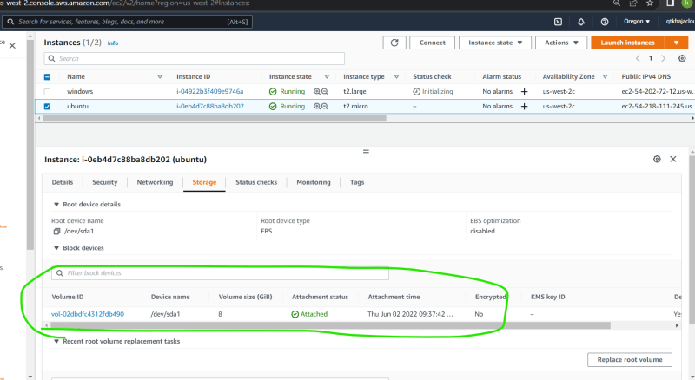

Windows Based EC2 instance  
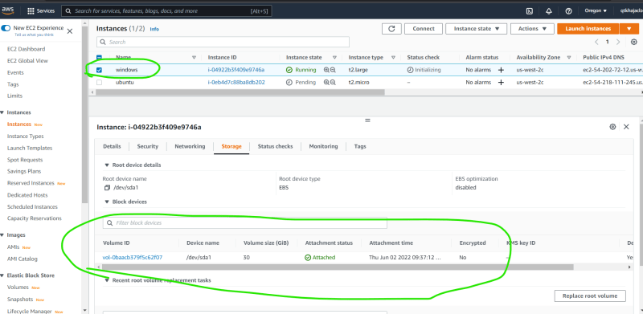

Login into linux machine and execute the following  
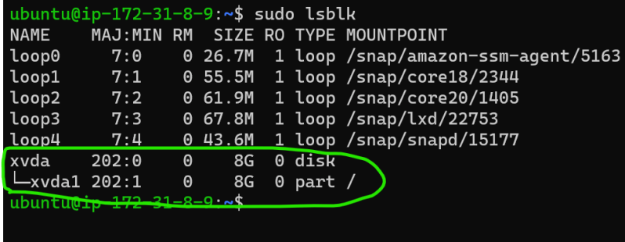  
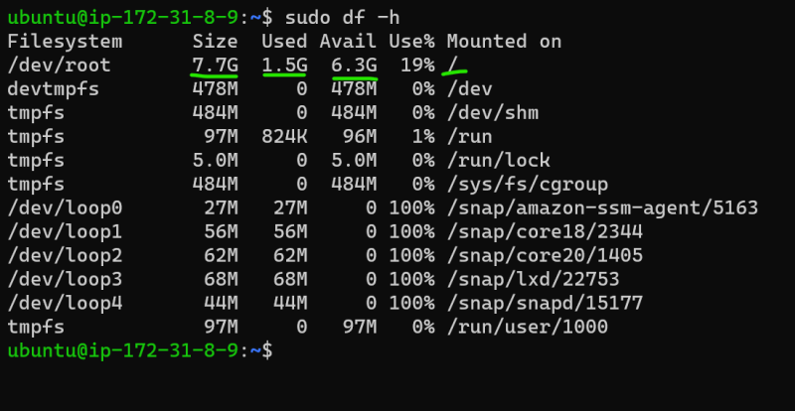

Login into windows server and explore the storage devices  
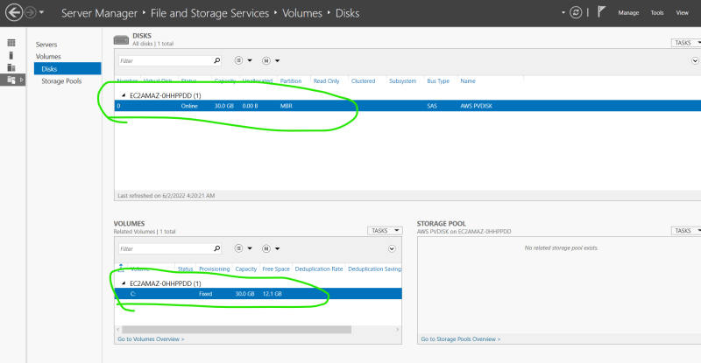  
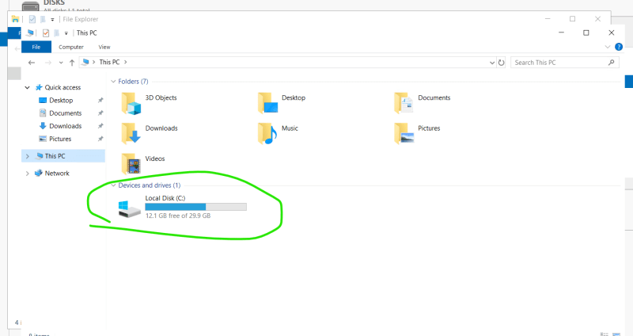

Now lets add an EBS volume to the linux instance  
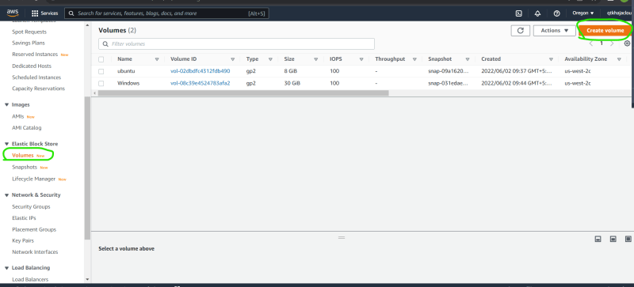  
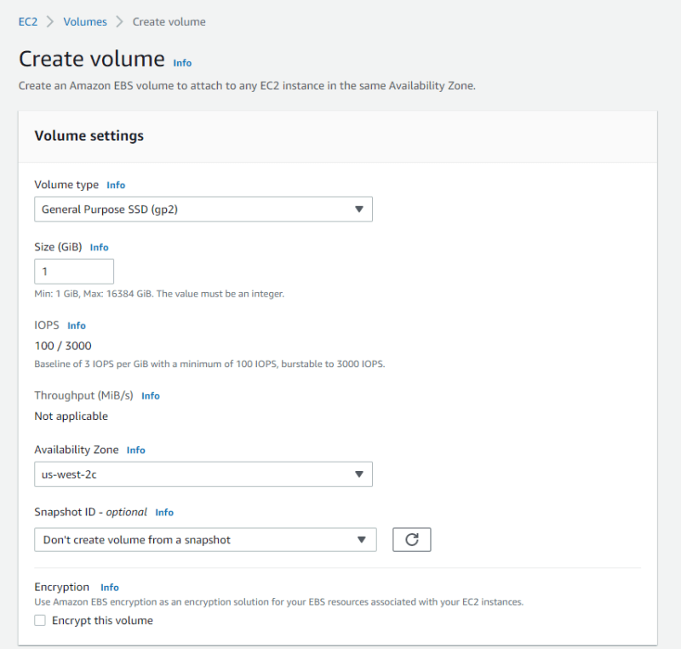  
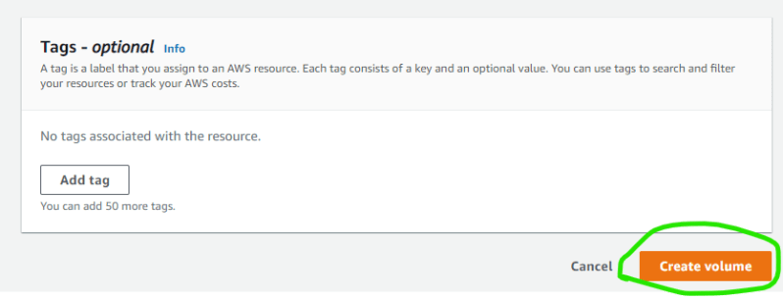  
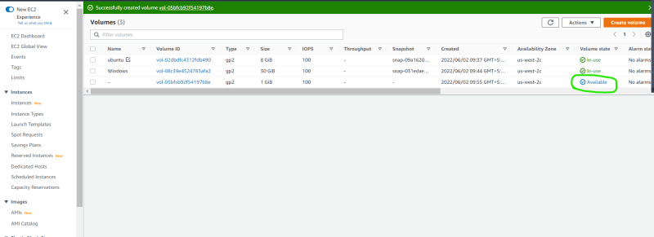  
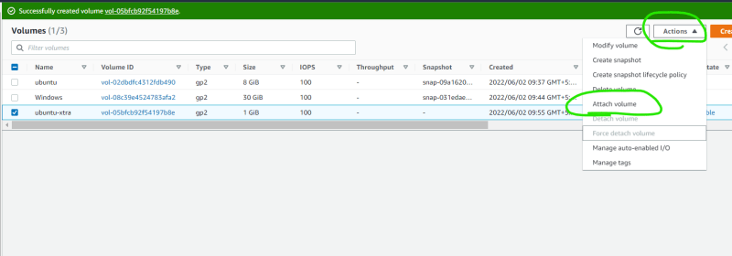  
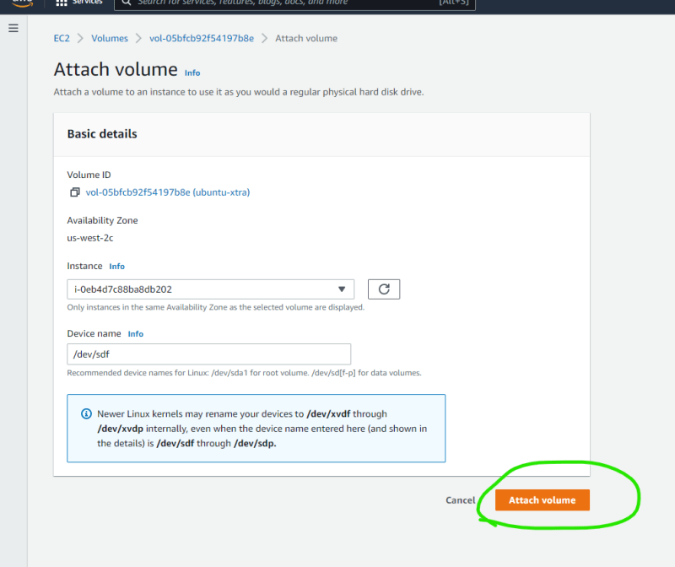  
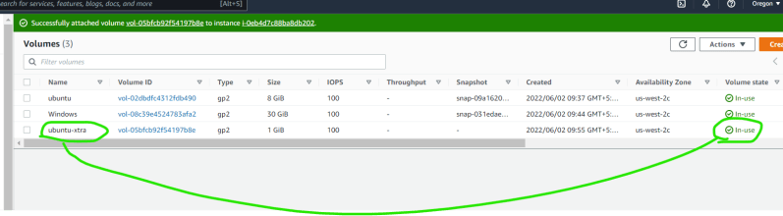  
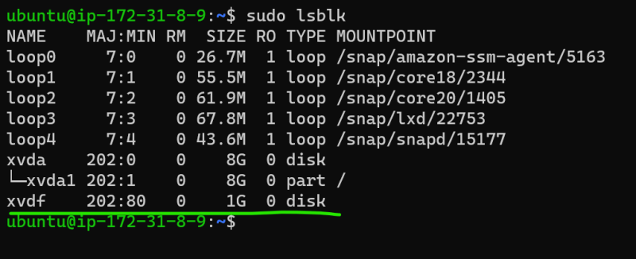

Once the block device is found, you can create partitions or format the disk with filesystem  
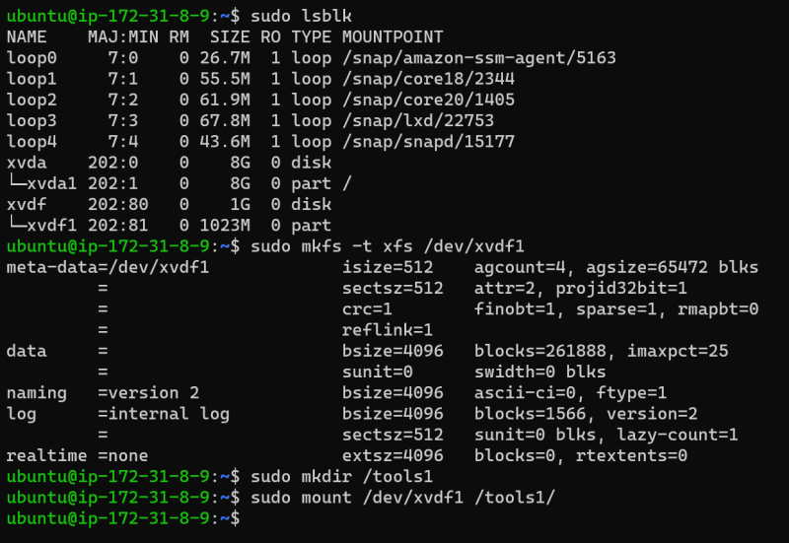  
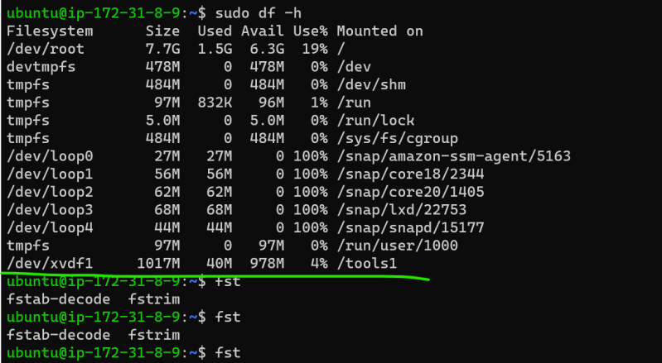

Now lets create some files  
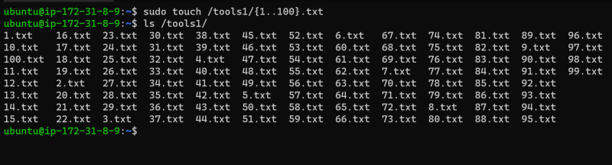

* Let’s repeat the same in windows (refer class room video)
* In AWS We can increase the size of volumes without restarting the servers  
  